|  |  |
| --- | --- |
| **Nicholl Directory 1884**  Comprises diary with Saints' days, special days, the phases of the moon, businesses advertisements, public information, religious tracts.  Looks as if it's an annual publication  **Mostly about Wantage and surrounding villages**  **Images of Faringdon pages follow:**  **Directory kindly loaned by John and Angie Nichol of Faringdon** | Nicholl dir p1.jpg |

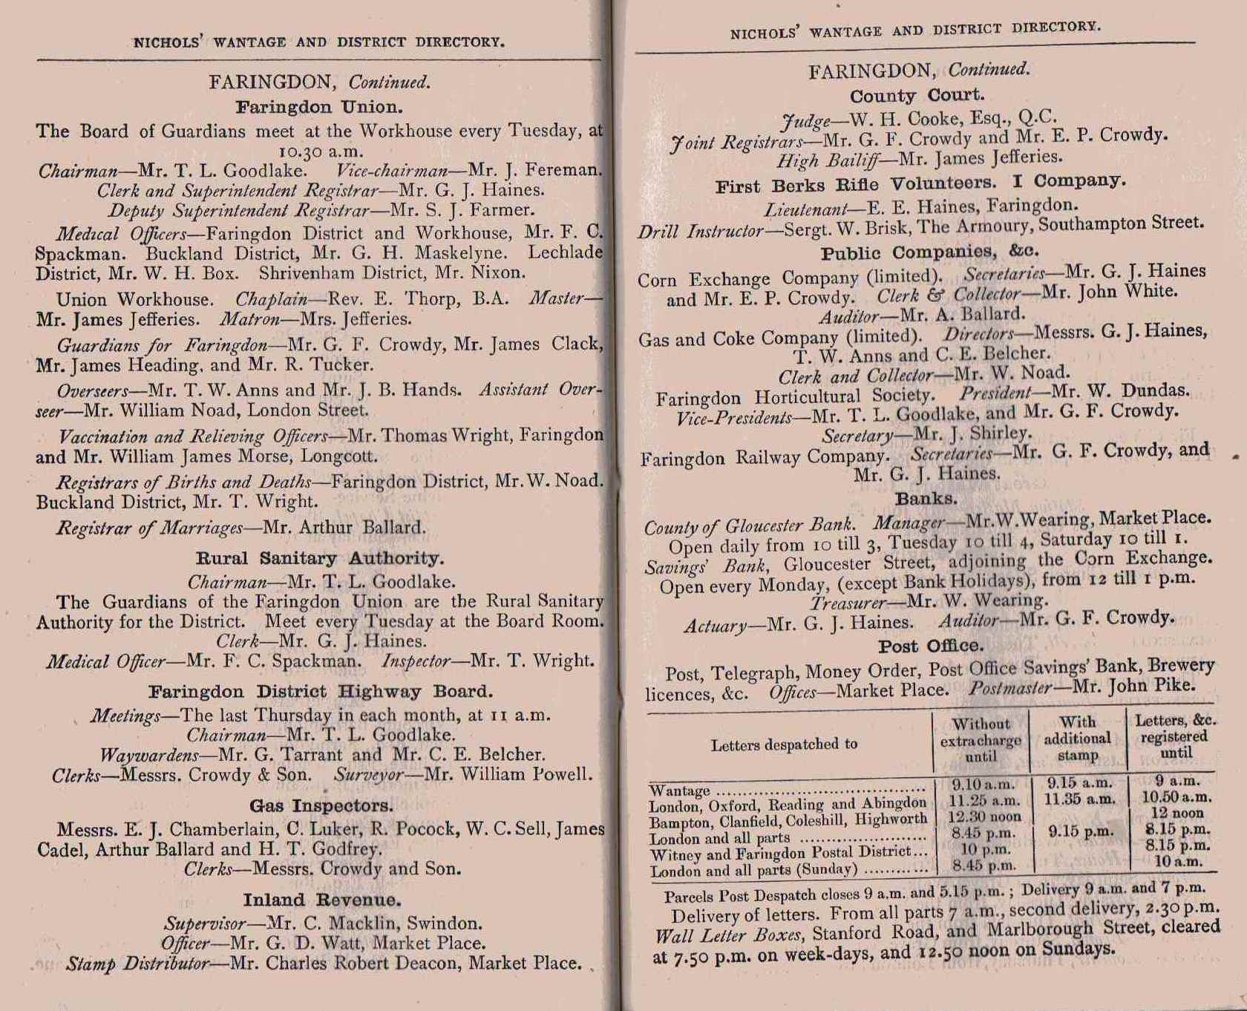

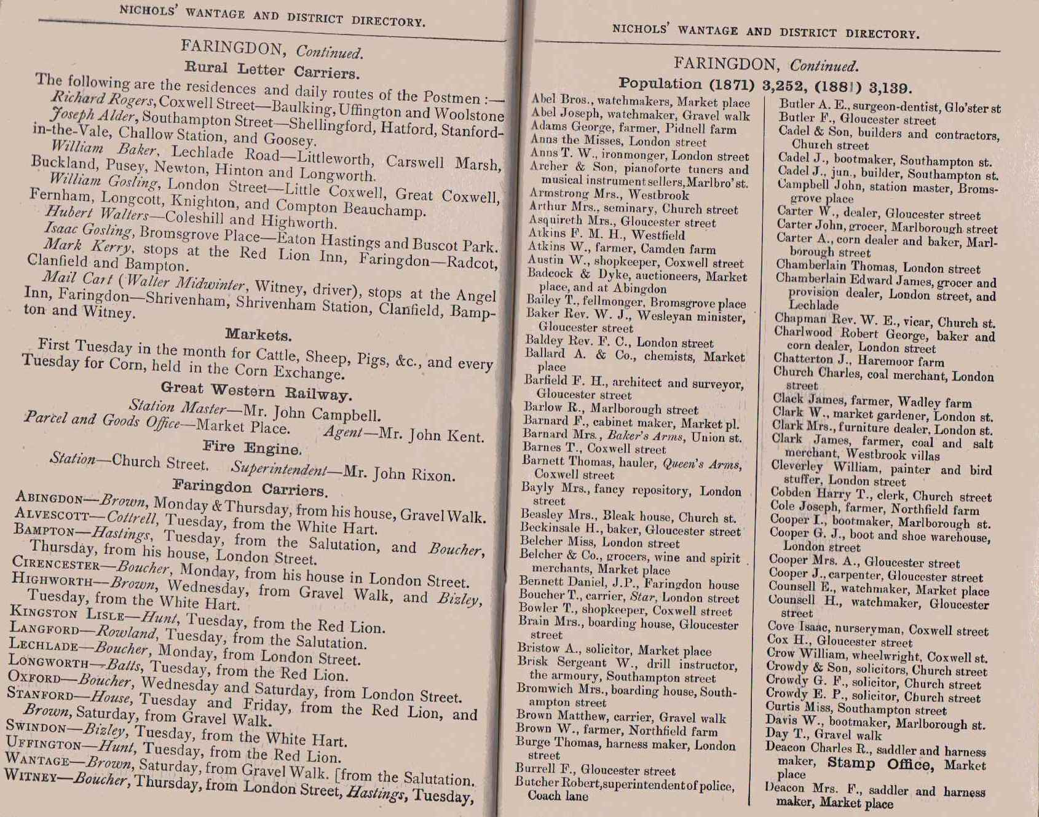

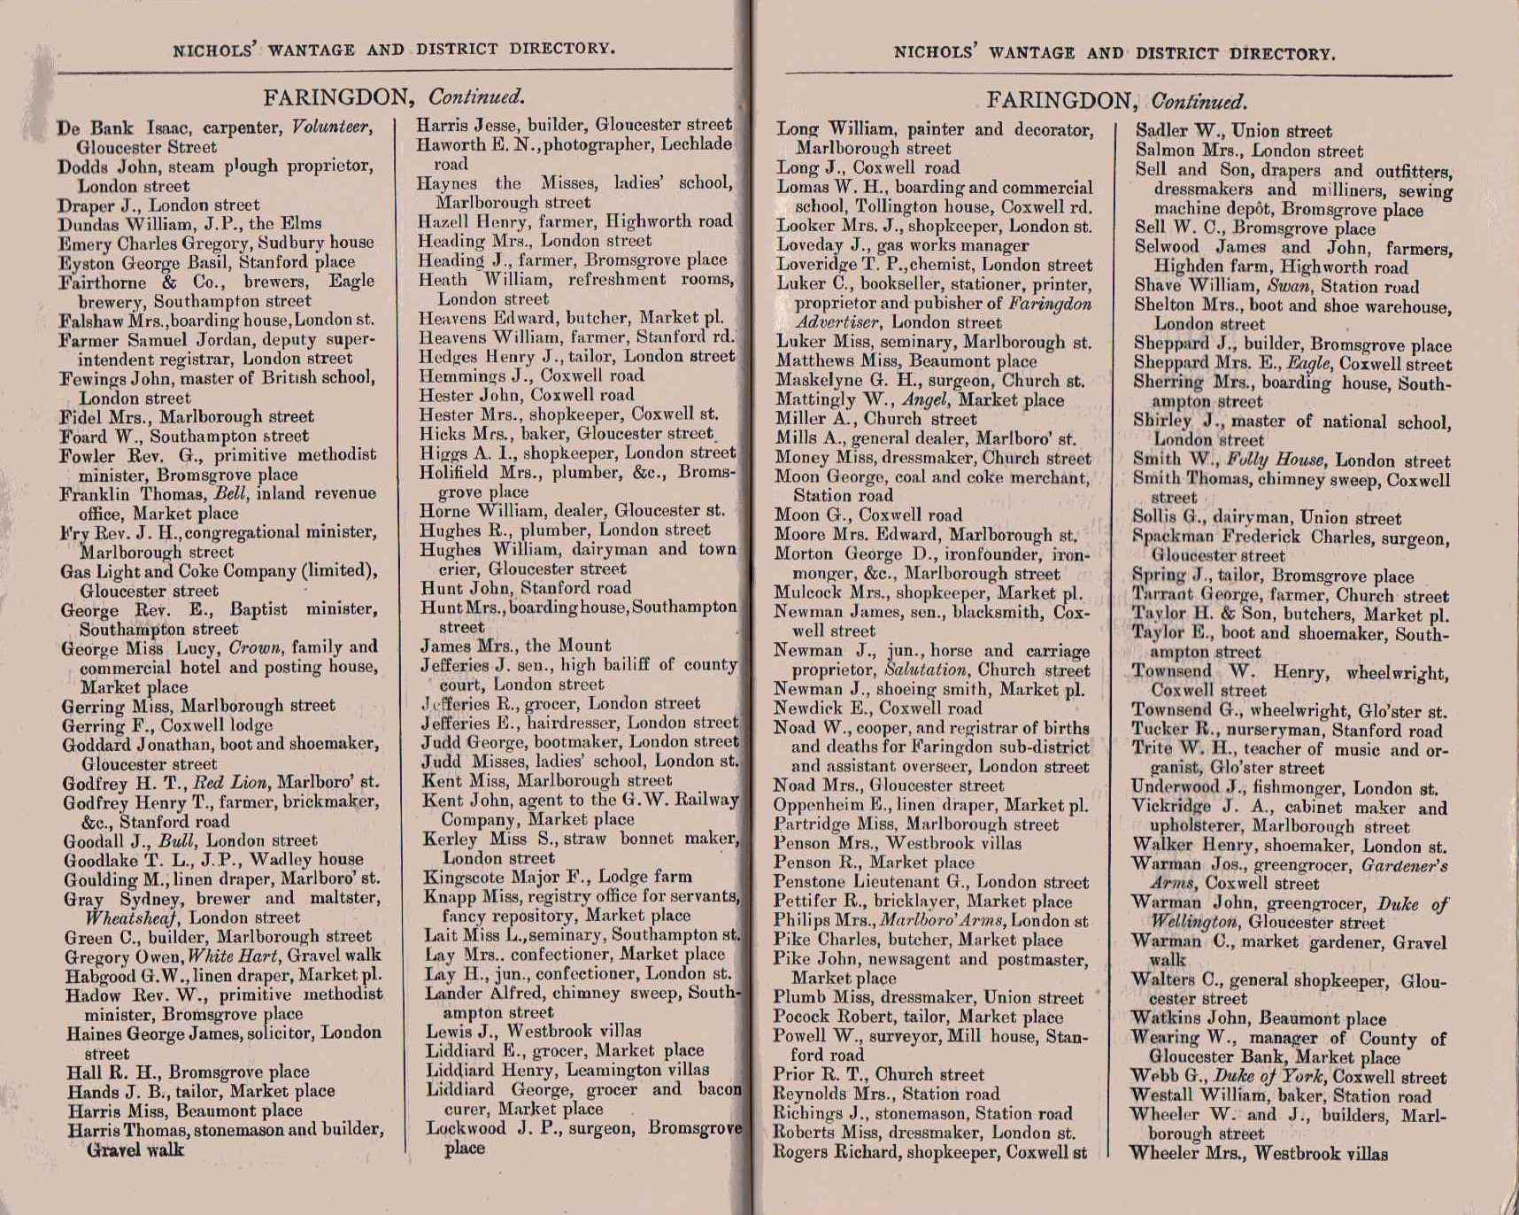

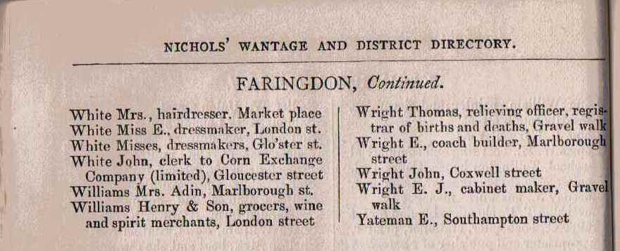

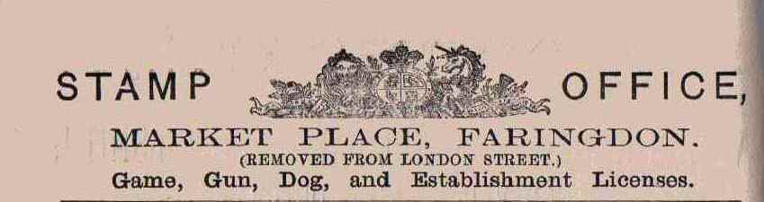

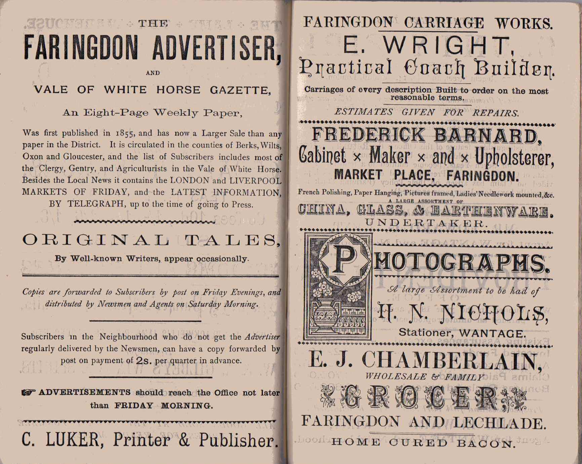

|  |  |
| --- | --- |
| Nicholl dir ballard chemist.jpg | Nicholl dir Eliza Lay.jpg |

