Oxfordshire LEADER Grants

A successful LEADER grant programme ran in Southern Oxfordshire from 2008 to 2013. 61 grants were awarded to a wide range of rural development projects including:

- microbrewery in redundant farm building
- refrigerated van for a delivery service
- farm shop and cafe
- cold store for turkey and goose sales
- diversification into on farm 'glamping'
- vac-packer for direct meat sales

- Average grant was about £20,000
- Total value of grants awarded £1.2m
- Grants levered in private sector and other funding in excess of £2.5m

In 2015 to 2020 Defra wants LEADER to cover more of rural Oxfordshire and 70% of all projects must directly support the rural economy. The remaining 30% of projects need to demonstrate that they are contributing to improving the local rural economy by, for example, increasing visitors to a particular area or providing an essential rural service.

Indicative Oxfordshire LEADER area 2015-2020

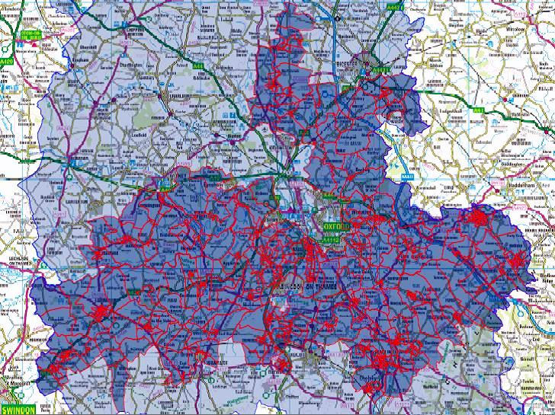

Local LEADER areas are limited to a maximum population of 150,000. Other parts of Oxfordshire could be covered by the Cotswolds, North Wessex Downs and Chilterns LEADER grant programmes.

To find out more contact

Amanda Holland, LEADER Project Officer, South Oxfordshire District Council

amanda.holland@southandvale.gov.uk Direct line: 01491 823177
Oxfordshire LEADER
LEADER rural grants 2015 to 2020
Potential Projects

A group representing businesses, community organisations and local government, with support from South Oxfordshire and Vale of White Horse district councils, is preparing an application for a share of LEADER funding which is being made available to help bring about projects to boost the rural economy across the country. LEADER is jointly funded by the EU and Defra.

Having information about the likely need for funding will support this bid and so if you have a potential project, please let us have a brief description by answering the following questions.

Your Name
Contact Details

Location of Project (inc. post code)
Stage of Project (e.g. idea/planning/underway)
A brief ‘one line’ description of the project (e.g. Build a farm shop)
Please provide details of how it will promote rural economic growth (e.g. create jobs, add value to farm or woodland produce, attract more visitors)
Estimate of Cost
Estimate of grant required (bearing in mind grant will not be more than 50% of cost and is likely to be £5,000 minimum and £30,000 maximum)

Which of the six national priorities will it support – you can choose more than one, but not all of them.
Priority | Tick if relevant
Support for increasing farm productivity
Support for micro and small enterprises and farm diversification
Support for rural tourism
Provision of rural services
Support for cultural and heritage activity
Support for increasing forestry productivity

Please return these details to amanda.holland@southandvale.gov.uk

Thank you

