In Memory of
Gunner HARRY KIBBLE
22958, D Battery 112th Brigade,
Camberwell’s Own Royal Field Artillery
Native of Eaton Hastings, Faringdon
Who died, age 20, on 8 October 1918
Son of Thomas and Mary Kibble,
of The Villa, Little Coxwell, Faringdon.
Remembered with honour
Faringdon, Little Coxwell and Easton Hastings
War Memorials and
BELLICOURT BRITISH CEMETERY

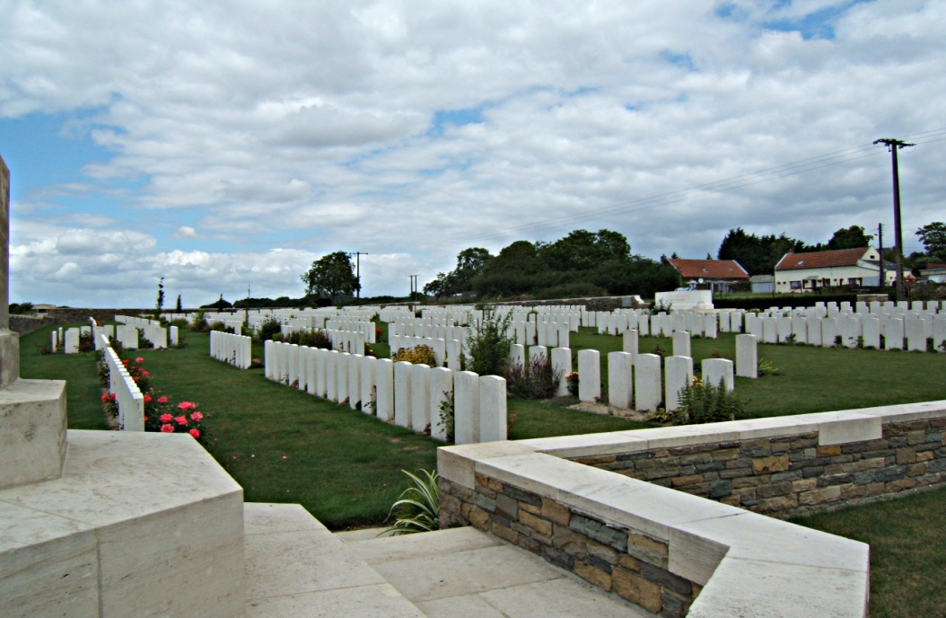
Commemorated in perpetuity by the Commonwealth War Graves Commission
Bellicourt is a village 13 km north of St. Quentin and 28 km south of Cambrai on the N44 road which connects the two cities. The Canal de St. Quentin passes under the village of Bellicourt in a tunnel 5 km long, built under the orders of Napoleon I. The Hindenburg Line ran west of the village, and the barges in the tunnel were used to shelter German reserves. About 5 km south of Bellicourt, where the canal is open, is the village of Bellenglise, where another great tunnel or dug-out was made by the Germans. On 29 September - 2 October 1918, the Battle of the St. Quentin Canal was fought. The 46th (North Midland) Division stormed the Hindenburg Line at Bellenglise and captured 4,000 prisoners and 70 guns. The 30th United States Division captured Bellicourt and Nauroy, which were cleared by the 5th Australian Division. The North Midland and Australian dead of this engagement fill most of the graves in Bellicourt British Cemetery. The cemetery was made after the battle, when 73 dead were buried in what is now Plot I. It was greatly enlarged after the Armistice, when graves were brought from the surrounding battlefields and the following smaller cemeteries. Bellicourt British Cemetery now contains 1,204 burials and commemorations of the First World War. 313 of the burials are unidentified but there are special memorials to 21 casualties known or believed to be buried among them. The cemetery was designed by Charles Holden.

Harry was the third son of Thomas and Mary Kibble who then lived in Oldfield, Buscot. The Faringdon Advertiser reported: He was wounded on July 18th 1916 (Somme) and is now in Whitchurch Hospital suffering from three separate wounds, one in the neck, the left shoulder and another in the stomach. A shrapnel shell burst right on to the gun they were serving. And some of the men had miraculous escapes, amongst these being his elder brother, Herbert, who was struck on the left breast, but thanks to a pocket bulging with books and correspondence the missile only inflicted a slight wound. He was, however, considerably bruised, and has been given a rest in the wagon lines. Gunner Harry Kibble is, we are pleased to state progressing very favourably.
Herbert survived the war, afterwards joining the Berkshire Constabulary; Harry Kibble was killed just five weeks before the end of the war.

