Badbury Hill Trails 2016

Questions and Answers

Two years ago the National Trust asked visitors what we could do to improve things at Badbury Hill.

There were three main requests. These were a bigger, better car park, ways to improve the mix between walkers and cyclists and dog waste bins.

In response, we put together a plan that will allow us to improve the natural environment of Badbury Hill and to continue protecting and enhancing this special place. This included the provision of new cycle trails that would allow both walkers and cyclists to enjoy Badbury Hill safely; an upgraded car park and dog waste bins. Around 200 people attended three local consultations in June 2015 to find out more about these plans.

**Why does the National Trust want to create cycle trails?**

**To foster a love of the outdoors** - Outdoor spaces have often been seen as the National Trust’s best kept secret. We want to play our part in helping to reconnect the nation with the outdoors. At the heart of the Trust’s strategy is improving access to and awareness of our many outdoor locations to encourage people to enjoy the unique pleasure of spending time in the countryside. Our plans for a wild play area for children and well-managed off-road cycling plays a part in this.

We want the next generation to grow up loving and caring for the British countryside. We want to provide facilities that appeal to them, giving them a positive connection with the outdoors so that they grow to love it, rather than feeling that it is not relevant and therefore not important to them.

Similar projects to that proposed at Badbury Hill have already been undertaken by the National Trust at Leigh Woods in Bristol, Plymbridge in Devon, Castle Ward in Northern Ireland, Wicken Fen in Cambridgeshire and Lanhydrock in Cornwall. They have been very successful in broadening appreciation of the countryside.

**Safety** - A primary reason for creating cycle trails at Badbury Hill is to improve safety. Currently, large numbers of mountain bikers roam the whole of the site and in places, build their own unmanaged trails. Walkers can’t predict where their route might intersect with a biker’s – and vice versa. Designated cycle trails will separate the two user groups and allow us to safely manage cycling on the site. And where there are intersections between walking and cycle routes, these can be signposted and managed.

**What will the cycle trails look like?**

We are proposing two new permanent cycle trails – a gentle family trail and a more demanding route with optional loops for the really adventurous.

The trails will be a maximum of 2m surfaced width with an average finished width of 1.2m. For the purposes of planning consent, a wider ‘corridor’ for the trails is submitted. This allows the final line of the trail to be moved slightly on the ground to accommodate twists and turns, avoid trees and create good sightlines at intersections

The trails will be constructed out of stone of a similar type to the other forestry access tracks within the woodland (not tarmac). Once landscaped and bedded in, the trails will look like any other trail on the site. Experience from other sites is that natural re-vegetation occurs rapidly following construction.

*Pictured: Leigh Woods, four months after construction*



**How will you manage safety?**

Freeride and downhill mountain bikers currently visit the site in significant numbers. Cycling access is currently unmanaged and in places mountain bikers are self-building trails. The proposed cycle trails will allow us to safely manage cycling on the site and there will be a new dedicated National Trust ranger who will oversee management of the site.

Cycle trails of the nature that we’re planning have been safely implemented at many sites across the UK. Through careful planning in the micro-design stage, the safety of both riders and walkers can be preserved.

For instance, when cycling routes cross walking routes, it will be flagged up to users using low key signage that is sympathetic to the natural site, so everyone is aware they are approaching an intersection. Pedestrians have the right of way.

Intersections will be avoided where cyclists are going downhill and the route will be designed so that there are clear sightlines at these points. Bends or natural features such as large rocks or logs can be used to slow down cyclists in these areas.

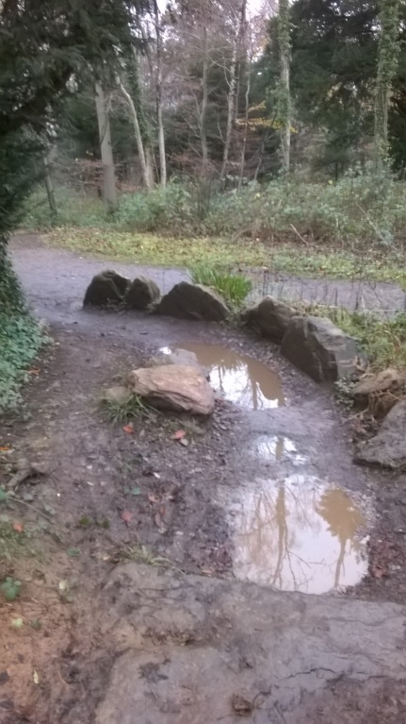

Walkers will be discouraged from walking the adventurous cycle trails as they are narrower than many footpaths and weave through the landscape much more. They also often use cambers that make walking on them difficult. There is nothing to stop walkers from using the cycle trails, but they’ll find the footpaths more appealing.

**Why is the National Trust partnering British Cycling?**

The partnership with British Cycling enables us to fulfil our aim of encouraging people and new audiences to enjoy the outdoors and come to love our special places.

British Cycling is the national governing body for cycling funded by Sports England. A major part of its remit is to encourage cycling through recreational programmes suited to all different age groups and abilities for the health of the nation.

British Cycling’s involvement means that its development staff and coaches will proactively work with community groups, local clubs and schools in the towns and villages around Badbury Hill to encourage people to take up cycling through holiday programmes, coaching and clubs. Go-Ride is British Cycling’s national development programme for young people and clubs and last year it delivered 515,000 cycling opportunities to young people and created 300 Go-Ride clubs.

**Will there be cycling events? How often? On what scale?**

British Cycling will need to request permission from the National Trust every time they wish to organise competitions and events on Badbury’s cycle trails. In the first year of the trails this is likely to be two or three events, with the option to increase the frequency if they go well.

Once every few years, British cycling may request permission to hold a national event. This will need to be kept manageable in terms of its size as capacity is limited at this site. Existing national events usually involve no more than 200 participants. To put this in context, 237 children and their families came to Badbury Hill on Easter Sunday in 2015 between the hours of 11am and 2.30pm for the Cadbury Easter Egg Trail.

The British Cycling events held at Badbury will mainly be for local clubs and will usually be held midweek in the evenings, starting at 6/7pm and finishing by 8/9pm. British Cycling reports that similar events at similar sites in the region usually have a maximum of 50-60 participants. Participants are contained on the site and are not racing on the roads.

The National Trust will work with British Cycling to time events so that they occur when Badbury is not busy. We have already installed ‘car counters’ at the entrance to Badbury Hill car park so that we know when those peak periods are.

**Won’t these trails spoil my walk?**

Walking routes will not be affected. Walkers will be able to follow all the routes they usually follow, but with advance warning of the rare occasions where they might meet a cyclist. We also are installing new dog waste bins to encourage owners to pick up after their dogs. This means that walking at Badbury Hill is likely to become a more pleasant and tranquil experience.

**Won’t these trails mean a less exciting ride for mountain bikers?**

The ‘blue’ route has been designed with one of Britain’s leading cycle trail builders. They are competition-standard trails with challenging ‘red’ loops for experienced cyclists.

A section of the woodland has also been set aside for those who enjoy creating their own organic trails and jumps. This area will be managed by a group of volunteer cyclists and National Trust staff.

**Will the ancient hill fort at Badbury Clump be put at risk?**

No. Designated cycle trails will draw cyclists away from Badbury Clump, minimising erosion to the precious Iron Age hill fort, which is a Scheduled Ancient Monument. National Trust archaeologists are preparing a management plan specifically aimed at protecting the Clump, which includes changes to the car park to move cars further away from the edge of the site. We will work with Historic England to implement this through better signage, more regular monitoring and by taking proactive action to stop damaging activities, including cycling, from taking place on the hill fort.

**Will these trails affect the natural environment at Badbury Hill?**

No. The National Trust is a body with conservation at its core and will always adhere to statutory requirements and recognised best practice in wildlife conservation. At Badbury Hill the new cycle trails will encourage riders to follow the trails, rather than roaming the whole woodland. This will minimise erosion to the site and damage to the woodland floor.

The trails will be micro-designed in sympathy with the existing environment. For instance, if there’s the option to go around a tree or clump of bluebells, that’s the route that will be taken.

The Badbury Hill Trails project also offers opportunities to enhance the site for wildlife. Badbury Hill was created as a conifer plantation for the timber industry and has limited wildlife value. The National Trust plans to gradually restore the plantation to native British broad-leaved woodland, which offers a much richer and more diverse habitat.

**Won’t the site and surrounding roads be inundated with traffic?**

We estimate that as a result of installing the cycle trails, Badbury Hill will receive up to 30 additional car visits per day. This figure is based on experience from other sites.

‘Car counter’ sensors have been in place at Badbury Hill since mid-October 2015 and at this time of year is averaging 100 car visits per day. However, at peak periods such as Easter and bluebell time, this number rises dramatically.

As mentioned in the ‘cycling events’ section, British Cycling will need to request permission from the National Trust every time they wish to organise competitions and events on Badbury’s cycle trails.

Cycling events will involve up to 60 participants two or three times a year, mid-week in the evenings. Once every few years, a national event involving around 200 participants may be held. To put this in context, 237 children and their families came to Badbury Hill on Easter Sunday in 2015 between the hours of 11am and 2.30pm for the Cadbury Easter Egg Trail, so this number of visitors is not unprecedented

**Will the car park be enlarged?**

The car park will be resurfaced and landscaped to be able to accommodate almost twice as many cars – around 100 spaces. This capacity is required to service the current high usage of the site at peak periods, for instance at Easter and bluebell time.

The entrance to the car park will also be widened to make it safer to enter and exit.

**Will you introduce car park charging?**

We have a responsibility to protect what we look after forever and for everyone, so we need to ensure we have the funds available to do so. Currently, Badbury Hill costs around £20k per year plus a full time member of staff and dozens of volunteers to maintain. In order to pay for the conservation and access work of Badbury Hill we will need to look at introducing charging for non-members at this site. This is in line with many of our sites across the country. Similar sites charge £2 for two hours and £4 for longer than two hours.

National Trust members will continue to park for free. Free parking is just one of our many member benefits.

**Will there be any other facilities on the site, such as toilets or a café?**There are plans to consider the introduction of toilets and refreshments to the site in 2018. These will be in the form of freestanding pod units in the car park area.

There are also plans to create a wild play area for children.

**Further information:**

This document will be updated as more queries come in. To view the latest version please visit [www.nationaltrust.org.uk/badbury-hill](http://www.nationaltrust.org.uk/badbury-hill).

If you have a specific enquiry please email at the National Trust at [buscotandcoleshill@nationaltrust.org.uk](mailto:buscotandcoleshill@nationaltrust.org.uk)

or call 01793 762209